

**BOOKLET 1**

**SCIENCE DEPARTMENT**

**YEAR 11**

**HUMAN BIOLOGICAL SCIENCE EXAMINATION**

**SEMESTER 1, 2009**

**Student Name:** ______________________________________ **Form:** _______________

**Teacher Name:** ______________________________________

**Time allowed for this paper**

Reading time before commencing work: 10 minutes

Working time for paper: 2.5 hours

**Materials required / recommended for this paper**

To be provided by the supervisor

**Booklet 1** – Multiple Choice Question Booklet

**Booklet 2** – Multiple Choice Answer Sheet and Extended Answer Lined Paper

**Booklet 3** – Short Answer Questions and Extended Answer Questions

To be provided by the candidate

*Standard items:* Pens, pencils, eraser or correction fluid, ruler

*Special items:* A 2B, B or HB pencil for the separate Multiple Choice Answer Sheet and calculators satisfying the conditions set by the Curriculum Council for this subject

*(Graphics type calculators are* ***NOT*** *permitted).*

**Important note to candidates**

No other items may be taken into the examination room. It is **your** responsibility to ensure that you do not have any unauthorised notes or other items of a non-personal nature in the examination room. If you have any unauthorised material with you, hand it to the supervisor **before** reading any further.

**Structure of this paper**

|  |  |  |  |
| --- | --- | --- | --- |
| **Section** | **Number of questions available** | **Number of questions to be attempted** | **Percentage of Total Score** |
| A Multiple Choice | 40 | 40 | /40 |
| B Short Answer questions | 20 | 20 | /40 |
| C Extended Answer questions: | 2 | 2 | /20 |
|  |  | **Total %** | **/100** |

**Instructions to candidates**

1. Answer the questions according to the following instructions.

**Section A** Answer ALL multiple choice questions by crossing out the letter of your choice on the Answer Sheet provided. Use 2B pencil here.

**Section B** Answer the questions in the spaces provided. Answers to be in BLUE or BLACK biro. GRAPHS and DRAWINGS to be in pencil.

**Section C** Answer BOTH questions in this section.

Write your answers on the lined paper provided.

2. You should note that the space made available for an answer is not necessarily an indication of the length of the answer.

3. You must not take any of the examination booklets away from the examination room.

**SECTION A MULTIPLE CHOICE (40 marks)**

*Mark your answers on the Multiple Choice Answer Sheet in* ***Booklet 2****.*

1. The series of interconnecting canals that transport fluid through a cell are called:
   1. endoplasmic reticulum
   2. centrioles
   3. golgi bodies
   4. mitochondria
2. Any group of cells of similar structure that perform a specific task are referred to as:
   1. a system
   2. a tissue
   3. an organ
   4. a nerve
3. Which of the following is the site for aerobic respiration?
   1. nucleus
   2. cytoplasm
   3. mitochondria
   4. ribosomes
4. During the process of mitosis there are a number of clearly visible stages. During which stage does replication of DNA occur?
   1. interphase
   2. prophase
   3. metaphase
   4. anaphase
5. Which of the following organelles would you expect to be more numerous in a muscle cell than in a bone cell?
   1. ribosomes
   2. mitochondria
   3. centrioles
   4. lysosomes
6. Students observed a cell under high power of a microscope using a 10X ocular lens and a 40X objective lens. The cell appeared to have the width of 24mm. If the objective lens was changed to 10X, what would be the width of the cell?
   1. 96mm
   2. 24mm
   3. 6mm
   4. 12mm
7. ATP is essential to every living cell because it:
   1. stores energy released during the breakdown of ADP
   2. speeds up the digestion of food
   3. stores energy in a form that is readily available
   4. reacts with energy from glucose to form ADP
8. Cells use as their main source of energy which of the following?
   1. sugar
   2. glucose
   3. amino acids
   4. fats
9. A student made a wet mount of a letter that she observed under the microscope on low power as ‘d’. What letter did she make the slide of?
   1. ‘b’
   2. ‘p’
   3. ‘d’
   4. ‘q’
10. Which of the following lists states the major levels of taxonomic classification in order of decreasing diversity within each level?
    1. species, genus, order, class, family
    2. class, order, family, genus, species
    3. order, class, species, family, genus
    4. class, order, genus, family, species
11. An enzyme is a/an:
    1. chemical messenger
    2. carbohydrate
    3. organic catalyst
    4. inorganic substance
12. A membrane which allows the passage of certain molecules only is said to be:
    1. fully permeable
    2. permeable
    3. impermeable
    4. differentially permeable
13. Systolic and diastolic blood pressure in a healthy young adult should be approximately:
    1. 100mm and 120mm of Hg respectively
    2. 80mm and 100mm of Hg respectively
    3. 80mm and 120mm of Hg respectively
    4. 120mm and 80mm of Hg respectively

14. The greatest work effort of the cardiac muscle is exerted by the:

(a) right atrium

(b) right ventricle

(c) left atrium

(d) left ventricle

15. Oxygenated blood enters the heart in the:

1. right atrium
2. right ventricle
3. left ventricle
4. left atrium

16. The period in which a heart chamber fills is called:

(a) systole

(b) palpitation

(c) diastole

(d) dilation

17. Which one of the following is NOT involved in the clotting mechanism of blood?

1. fibrinogen

(b) blood platelets

(c) leucocytes

(d) erythrocytes

18. Which blood group is a “universal recipient”?

(a) A

(b) B

(c) O

(d) AB

19. The following four statements are about the events occurring during different phases of the cardiac cycle.

(I) Atrial systole is the phase of active contraction of the atria.

(II) Ventricular diastole is the period during which filling of the ventricles occurs.

(III) Blood enters the right atrium from the pulmonary veins during atrial diastole.

(IV) Blood enters the aorta and the pulmonary arteries during ventricular systole.

Which of the above statements is CORRECT?

(a) (I) and (II) only

(b) (I), (II) and (IV) only

(c) (II), (III) and (IV) only

(d) all are correct

20. The openings between the atria and the ventricles are guarded by atrio-ventricular valves. The valve between the right atrium and the right ventricle is known as the:

(a) mitral valve

(b) semi-lunar valve

(c) bicuspid valve

(d) tricuspid valve

21. Blood plasma is mainly composed of:

(a) haemoglobin

(b) antibodies

(c) blood cells

(d) water

22. Carbon dioxide travels:

1. as gas bubbles in the plasma
2. partly in the red blood cells and partly dissolved in the plasma as bicarbonate ions [HCO3 - ]
3. in the white blood cells
4. entirely in the red blood cells

Question 23 refers to the following graph:

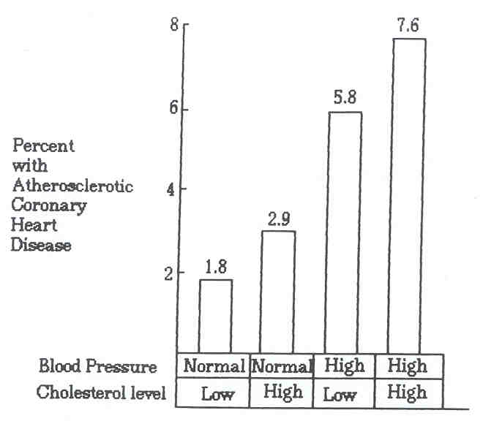

23. The graph above shows:

(a) the most important factor contributing to atherosclerosis is the amount of cholesterol in the blood

(b) high blood pressure and low cholesterol contribute more to atherosclerosis than high cholesterol

(c) atherosclerosis is more likely with high blood pressure and high cholesterol

(d) high blood pressure is the only factor which is implicated in atherosclerosis

24. When air is inhaled it flows through an air tube system to reach the air sacs. The system consists of the following:

(i) larynx (iv) bronchi

(ii) bronchioles (v) trachea

(iii) pharynx (vi) nasal cavity

What order of structures does the air flow through?

|  |  |  |  |
| --- | --- | --- | --- |
| **A** | **B** | **C** | **D** |
| nasal cavity  trachea  bronchi  pharynx  bronchioles  larynx | nasal cavity  bronchi  larynx  trachea  pharynx  bronchioles | nasal cavity  pharynx  larynx  trachea  bronchi  bronchioles | nasal cavity  bronchi  bronchioles  trachea  pharynx  larynx |

(a) A

(b) B

(c) C

(d) D

25. During the process of expiration the:

(a) diaphragm lowers

(b) ribs move upward and outward

(c) size of the thoracic cavity increases

(d) pressure inside the thoracic cavity increases

26. Which of the following is true of gaseous exchange through the wall of the alveolus?

(a) nett diffusion of oxygen is from alveoli to the blood capillaries

(b) nett diffusion of carbon dioxide is from alveoli to the blood capillaries

(c) diffusion of oxygen occurs at the same rate in both directions

(d) diffusion of carbon dioxide occurs at the same rate in both directions

27. Supplemental (expiratory reserve volume) air is that which:

(a) we can inhale by making an extra effort

(b) we can forcibly exhale after normal exhalation

(c) remains in the lungs after all other air has been forced out

(d) is given to deep sea divers as an emergency supply

28. The following table shows the composition of inhaled and exhaled air.

|  |  |  |
| --- | --- | --- |
|  | **Inhaled Air** | **Exhaled Air** |
| Oxygen | 20.7% | 14.8% |
| Carbon dioxide | 0.04% | 4.3% |
| Nitrogen | 79.0% | 79.5% |
| Water vapour | Same as atmosphere | Higher than atmosphere |
| Temperature | Same as atmosphere | Higher than atmosphere |

Which of the following statements are TRUE?

(I) Exhaled air has a lower concentration of oxygen but a higher concentration of carbon dioxide and water vapour.

(II) The carbon dioxide content in exhaled air is increased 100 times due to excretion as waste through the alveoli.

(III) The water vapour in exhaled air is derived from the evaporation along the respiratory tract.

(IV) The temperature of the exhaled air is higher because the air is warmed by the surrounding air near the nostrils.

(a) (I) and (III) only

(b) (I), (II), (III), (IV)

(c) (II) and (IV) only

(d) (I), (II) and (III)

29. When air is inhaled it flows through the air tube system to reach the air sacs. Which labelled part of the system contains the vocal cords?

Air tube system

Larynx Bronchioles Pharynx Bronchi Trachea Nasal cavity

**A B C D E F**

(a) A

(b) B

(c) C

(d) D

30. Many children in Australia suffer from asthma. Wheezing in asthma would be directly produced by:

(a) constriction of the bronchi and bronchioles

(b) grass pollens in the air

(c) mucus obstructing the nasal passages

(d) atmospheric pollution

31. Digested lipids would be in the form of:

(a) amino acids and glucose

(b) glucose and glycerol

(c) fatty acids and sucrose

(d) fatty acids and glycerol

32. Which is NOT a function of saliva?

(a) lubricates the mouth

(b) contains antibodies that kill bacteria

(c) dissolves food so the taste receptors can be stimulated

(d) mechanical digestion

33. Cardiovascular disease is presently the most serious health problem in Australian society. The commonest cause of this disease is hypertension (high blood pressure). Which of the following suggestions is recommended to prevent hypertension?

(a) moderately smoking, drinking and eating anything

(b) regular exercise and a careful dietary program

(c) limiting energy and salt intake, regular daily exercise, relaxation sessions and no smoking

(d) none of the above

34. The main function of the large intestine is:

(a) absorption of bile

(b) absorption of fatty acids and glycerol

(c) absorption of water

(d) absorption of blood

35. In mammals, most enzymes cease to function when they pass from one part of the alimentary tract to another. Which one of the following statements is the most likely explanation for the generalisation?

(a) different substrates require a variety of enzymes

(b) enzymes are affected by temperature changes

(c) some enzymes will only operate in a relatively narrow pH range

(d) absorption of the products of digestion has occurred and enzyme reaction is no longer necessary

36. Which of the following contains a body part that is not involved in digestion?

(a) stomach, liver and gall bladder

(b) gall bladder, liver and colon

(c) stomach, duodenum and liver

(d) stomach, trachea and liver

37. Which of the following are necessary for protein synthesis?

(a) amino acids, DNA, ADP and phosphate

(b) amino acids, ATP, phosphate and energy

(c) amino acids, DNA, enzyme and energy

(d)amino acids, ADP, enzyme and phosphate

38. Which of the following best describes osmosis?

(a) the movement of molecules from an area of higher concentration to one of lower concentration

(b) the ability of a membrane to regulate the molecules passing through it

(c) the movement of water through a differentially semi-permeable membrane

(d) the process of transporting molecules against a concentration gradient

39. A guide to whether an individual is overweight is calculated using the body mass index. This is calculated in the following way.

|  |  |  |
| --- | --- | --- |
| BMI | = | weight (kg) |
| height x height (m) |

To interpret the results a standardised chart has been constructed.

|  |  |
| --- | --- |
| **Condition** | **BMI** |
| Underweight | 19.9 or less |
| Acceptable weight | 20 - 25 |
| Overweight | 25.1 - 30 |
| Obese | 30.1 - 40 |
| Extreme obesity | 40.1 or more |

If a 1.57m woman weighed 63kg, into which category would she fall?

(a) underweight

(b) overweight

(c) acceptable weight

(d) obese

40. Consider the graph below of a man’s breathing rate:

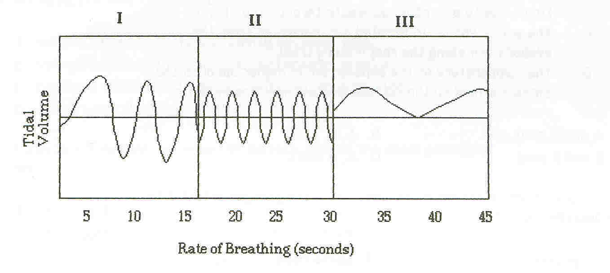

The average breathing rate for this man in an awake, sitting position was

12 breaths/minute.

Which section/s of the graph indicate/s a process of replacing the greatest oxygen deficiency?

1. I
2. II
3. III
4. I and III

**END OF SECTION A**

**BOOKLET 2**

**HUMAN BIOLOGICAL SCIENCE**

**SEMESTER 1 EXAM**

**MULTIPLE CHOICE ANSWER SHEET**

**STUDENT NAME: _____________________________________________**

**TEACHER NAME: _____________________________________________**

***Please indicate your answer with a cross (X) within the box.***

|  |  |  |  |  |  |  |  |  |  |  |
| --- | --- | --- | --- | --- | --- | --- | --- | --- | --- | --- |
| **1** | A | B | C | D |  | **21** | A | B | C | D |
| **2** | A | B | C | D |  | **22** | A | B | C | D |
| **3** | A | B | C | D |  | **23** | A | B | C | D |
| **4** | A | B | C | D |  | **24** | A | B | C | D |
| **5** | A | B | C | D |  | **25** | A | B | C | D |
| **6** | A | B | C | D |  | **26** | A | B | C | D |
| **7** | A | B | C | D |  | **27** | A | B | C | D |
| **8** | A | B | C | D |  | **28** | A | B | C | D |
| **9** | A | B | C | D |  | **29** | A | B | C | D |
| **10** | A | B | C | D |  | **30** | A | B | C | D |
| **11** | A | B | C | D |  | **31** | A | B | C | D |
| **12** | A | B | C | D |  | **32** | A | B | C | D |
| **13** | A | B | C | D |  | **33** | A | B | C | D |
| **14** | A | B | C | D |  | **34** | A | B | C | D |
| **15** | A | B | C | D |  | **35** | A | B | C | D |
| **16** | A | B | C | D |  | **36** | A | B | C | D |
| **17** | A | B | C | D |  | **37** | A | B | C | D |
| **18** | A | B | C | D |  | **38** | A | B | C | D |
| **19** | A | B | C | D |  | **39** | A | B | C | D |
| **20** | A | B | C | D |  | **40** | A | B | C | D |

**SECTION C EXTENDED ANSWERS (40 marks)**

________________________________________________________________________________________________________________________________________________________________________________________________________________________________________________________________________________________________________________________________________

__________________________________________________________________________________________________________________________________________________________________________________________________________________________________________________________________________________________________________________________________________________________________________________________________________________________

__________________________________________________________________________________________________________________________________________________________________________________________________________________________________________________________________________________________________________________________________________________________________________________________________________________________

__________________________________________________________________________________________________________________________________________________________________________________________________________________________________________________________________________________________________________________________________________________________________________________________________________________________

__________________________________________________________________________________________________________________________________________________________________________________________________________________________________________________________________________________________________________________________________________________________________________________________________________________________

____________________________________________________________________________________________________________________________________________________________________

________________________________________________________________________________________________________________________________________________________________________________________________________________________________________________________________________________________________________________________________________

__________________________________________________________________________________________________________________________________________________________________________________________________________________________________________________________________________________________________________________________________________________________________________________________________________________________

__________________________________________________________________________________________________________________________________________________________________________________________________________________________________________________________________________________________________________________________________________________________________________________________________________________________

__________________________________________________________________________________________________________________________________________________________________________________________________________________________________________________________________________________________________________________________________________________________________________________________________________________________

__________________________________________________________________________________________________________________________________________________________________________________________________________________________________________________________________________________________________________________________________________________________________________________________________________________________

____________________________________________________________________________________________________________________________________________________________________

__________________________________________________________________________________

______________________________________________________________________________________________________________________________________________________________________________________________________________________________________________________

__________________________________________________________________________________________________________________________________________________________________________________________________________________________________________________________________________________________________________________________________________________________________________________________________________________________

__________________________________________________________________________________________________________________________________________________________________________________________________________________________________________________________________________________________________________________________________________________________________________________________________________________________

__________________________________________________________________________________________________________________________________________________________________________________________________________________________________________________________________________________________________________________________________________________________________________________________________________________________

__________________________________________________________________________________________________________________________________________________________________________________________________________________________________________________________________________________________________________________________________________________________________________________________________________________________

________________________________________________________________________________________________________________________________________________________________________________________________________________________________________________________________________________________________________________________________________

____________________________________________________________________________________________________________________________________________________________________

__________________________________________________________________________________________________________________________________________________________________________________________________________________________________________________________________________________________________________________________________________________________________________________________________________________________

__________________________________________________________________________________________________________________________________________________________________________________________________________________________________________________________________________________________________________________________________________________________________________________________________________________________

__________________________________________________________________________________________________________________________________________________________________________________________________________________________________________________________________________________________________________________________________________________________________________________________________________________________

__________________________________________________________________________________________________________________________________________________________________________________________________________________________________________________________________________________________________________________________________________________________________________________________________________________________

________________________________________________________________________________________________________________________________________________________________________________________________________________________________________________________________________________________________________________________________________

__________________________________________________________________________________

____________________________________________________________________________________________________________________________________________________________________

__________________________________________________________________________________________________________________________________________________________________________________________________________________________________________________________________________________________________________________________________________________________________________________________________________________________

__________________________________________________________________________________________________________________________________________________________________________________________________________________________________________________________________________________________________________________________________________________________________________________________________________________________

__________________________________________________________________________________________________________________________________________________________________________________________________________________________________________________________________________________________________________________________________________________________________________________________________________________________

__________________________________________________________________________________________________________________________________________________________________________________________________________________________________________________________________________________________________________________________________________________________________________________________________________________________

________________________________________________________________________________________________________________________________________________________________________________________________________________________________________________________________________________________________________________________________________

__________________________________________________________________________________

____________________________________________________________________________________________________________________________________________________________________

__________________________________________________________________________________________________________________________________________________________________________________________________________________________________________________________________________________________________________________________________________________________________________________________________________________________

__________________________________________________________________________________________________________________________________________________________________________________________________________________________________________________________________________________________________________________________________________________________________________________________________________________________

__________________________________________________________________________________________________________________________________________________________________________________________________________________________________________________________________________________________________________________________________________________________________________________________________________________________

__________________________________________________________________________________________________________________________________________________________________________________________________________________________________________________________________________________________________________________________________________________________________________________________________________________________

________________________________________________________________________________________________________________________________________________________________________________________________________________________________________________________________________________________________________________________________________

__________________________________________________________________________________

____________________________________________________________________________________________________________________________________________________________________

__________________________________________________________________________________________________________________________________________________________________________________________________________________________________________________________________________________________________________________________________________________________________________________________________________________________

__________________________________________________________________________________________________________________________________________________________________________________________________________________________________________________________________________________________________________________________________________________________________________________________________________________________

__________________________________________________________________________________________________________________________________________________________________________________________________________________________________________________________________________________________________________________________________________________________________________________________________________________________

__________________________________________________________________________________________________________________________________________________________________________________________________________________________________________________________________________________________________________________________________________________________________________________________________________________________

________________________________________________________________________________________________________________________________________________________________________________________________________________________________________________________________________________________________________________________________________

__________________________________________________________________________________

____________________________________________________________________________________________________________________________________________________________________

__________________________________________________________________________________________________________________________________________________________________________________________________________________________________________________________________________________________________________________________________________________________________________________________________________________________

__________________________________________________________________________________________________________________________________________________________________________________________________________________________________________________________________________________________________________________________________________________________________________________________________________________________

__________________________________________________________________________________________________________________________________________________________________________________________________________________________________________________________________________________________________________________________________________________________________________________________________________________________

__________________________________________________________________________________________________________________________________________________________________________________________________________________________________________________________________________________________________________________________________________________________________________________________________________________________

________________________________________________________________________________________________________________________________________________________________________________________________________________________________________________________________________________________________________________________________________

__________________________________________________________________________________

__________________________________________________________________________________

__________________________________________________________________________________________________________________________________________________________________________________________________________________________________________________________________________________________________________________________________________________________________________________________________________________________

__________________________________________________________________________________________________________________________________________________________________________________________________________________________________________________________________________________________________________________________________________________________________________________________________________________________

__________________________________________________________________________________________________________________________________________________________________________________________________________________________________________________________________________________________________________________________________________________________________________________________________________________________

__________________________________________________________________________________________________________________________________________________________________________________________________________________________________________________________________________________________________________________________________________________________________________________________________________________________

____________________________________________________________________________________________________________________________________________________________________________________________________________________________________________________________________________________________________________________________________________________________________________________________________________________________________________________________________________________________________________

____________________________________________________________________________________________________________________________________________________________________________________________________________________________________________________________________________________________________________________________________________________________________________________________________________________________________________________________________________________________________________

__________________________________________________________________________________________________________________________________________________________________________________________________________________________________________________________________________________________________________________________________________________________________________________________________________________________

__________________________________________________________________________________________________________________________________________________________________________________________________________________________________________________________________________________________________________________________________________________________________________________________________________________________

__________________________________________________________________________________________________________________________________________________________________________________________________________________________________________________________________________________________________________________________________________________________________________________________________________________________

___________________________________________________________________________________________________________________________________________________________________________________________________________________________________________________________________________________________________________________________________________________________________________________________________________________________________________________________________________________________________________



**BOOKLET 3**

**SCIENCE DEPARTMENT**

**YEAR 11**

**HUMAN BIOLOGICAL SCIENCE EXAMINATION**

**SEMESTER 1, 2009**

**Student Name:** ______________________________________ **Form:** _______________

**Teacher Name:** ______________________________________

**Time allowed for this paper**

Reading time before commencing work: 10 minutes

Working time for paper: 2.5 hours

**Materials required / recommended for this paper**

To be provided by the supervisor

**Booklet 1** – Multiple Choice Question Booklet

**Booklet 2** – Multiple Choice Answer Sheet and Extended Answer Lined Paper

**Booklet 3** – Short Answer Questions and Extended Answer Questions

To be provided by the candidate

*Standard items:* Pens, pencils, eraser or correction fluid, ruler

*Special items:* A 2B, B or HB pencil for the separate Multiple Choice Answer Sheet and calculators satisfying the conditions set by the Curriculum Council for this subject.

*(Graphics type calculators are* ***NOT*** *permitted)*

**Important note to candidates**

No other items may be taken into the examination room. It is **your** responsibility to ensure that you do not have any unauthorised notes or other items of a non-personal nature in the examination room. If you have any unauthorised material with you, hand it to the supervisor **before** reading any further.

**Structure of this paper**

|  |  |  |  |
| --- | --- | --- | --- |
| **Section** | **Number of questions available** | **Number of questions to be attempted** | **Percentage of Total Score** |
| A Multiple Choice | 40 | 40 | /40 |
| B Short Answer questions | 20 | 20 | /40 |
| C Extended Answer questions: | 2 | 2 | /20 |
|  |  | **Total %** | **/100** |

**Instructions to candidates**

1. Answer the questions according to the following instructions.

**Section A** Answer ALL multiple choice questions by crossing out the letter of your choice on the Answer Sheet provided. Use 2B pencil here.

**Section B** Answer the questions in the spaces provided. Answers to be in BLUE or BLACK biro. GRAPHS and DRAWINGS to be in pencil.

**Section C** Answer BOTH questions in this section.

Write your answers on the lined paper provided.

2. You should note that the space made available for an answer is not necessarily an indication of the length of the answer.

3. You must not take any of the examination booklets away from the examination room.

|  |  |  |  |  |
| --- | --- | --- | --- | --- |
|  |  |  |  |  |

**SECTION B SHORT ANSWER QUESTIONS (105 marks)**

Answer Questions 41 – 50 by selecting the most appropriate biological term for each question. **DO NOT** use abbreviations.

1. Type of transport where materials are transported against a diffusion gradient.

_________________________________________

1. Breakdown of a glucose molecule in the cytoplasm of a cell.

_________________________________________

1. The nutrient group that contains carbon, hydrogen, oxygen and nitrogen.

_________________________________________

44. Process that takes place only in the sex organs to produce four haploid cells.

_________________________________________

1. An organic catalyst that speeds up the rate of reactions.

_________________________________________

46. Chemical molecule that takes the protein code instructions from the nucleus to the ribosomes.

_________________________________________

1. Structures in the cell that are responsible for spindle formation.

_________________________________________

1. Name of stomach enzyme activated by hydrochloric acid.

_________________________________________

1. The blind-ended tube found in a villus.

_________________________________________

1. The major blood vessel, which carries blood from the gut to the liver.

_________________________________________

(10 marks)

**Question 51** (Total 15 marks)

a) Diagram of a human cell. Name the cell structures represented by labels A-H.

(holes)

Glycogen granules

Nucleus

Vacuoles forming

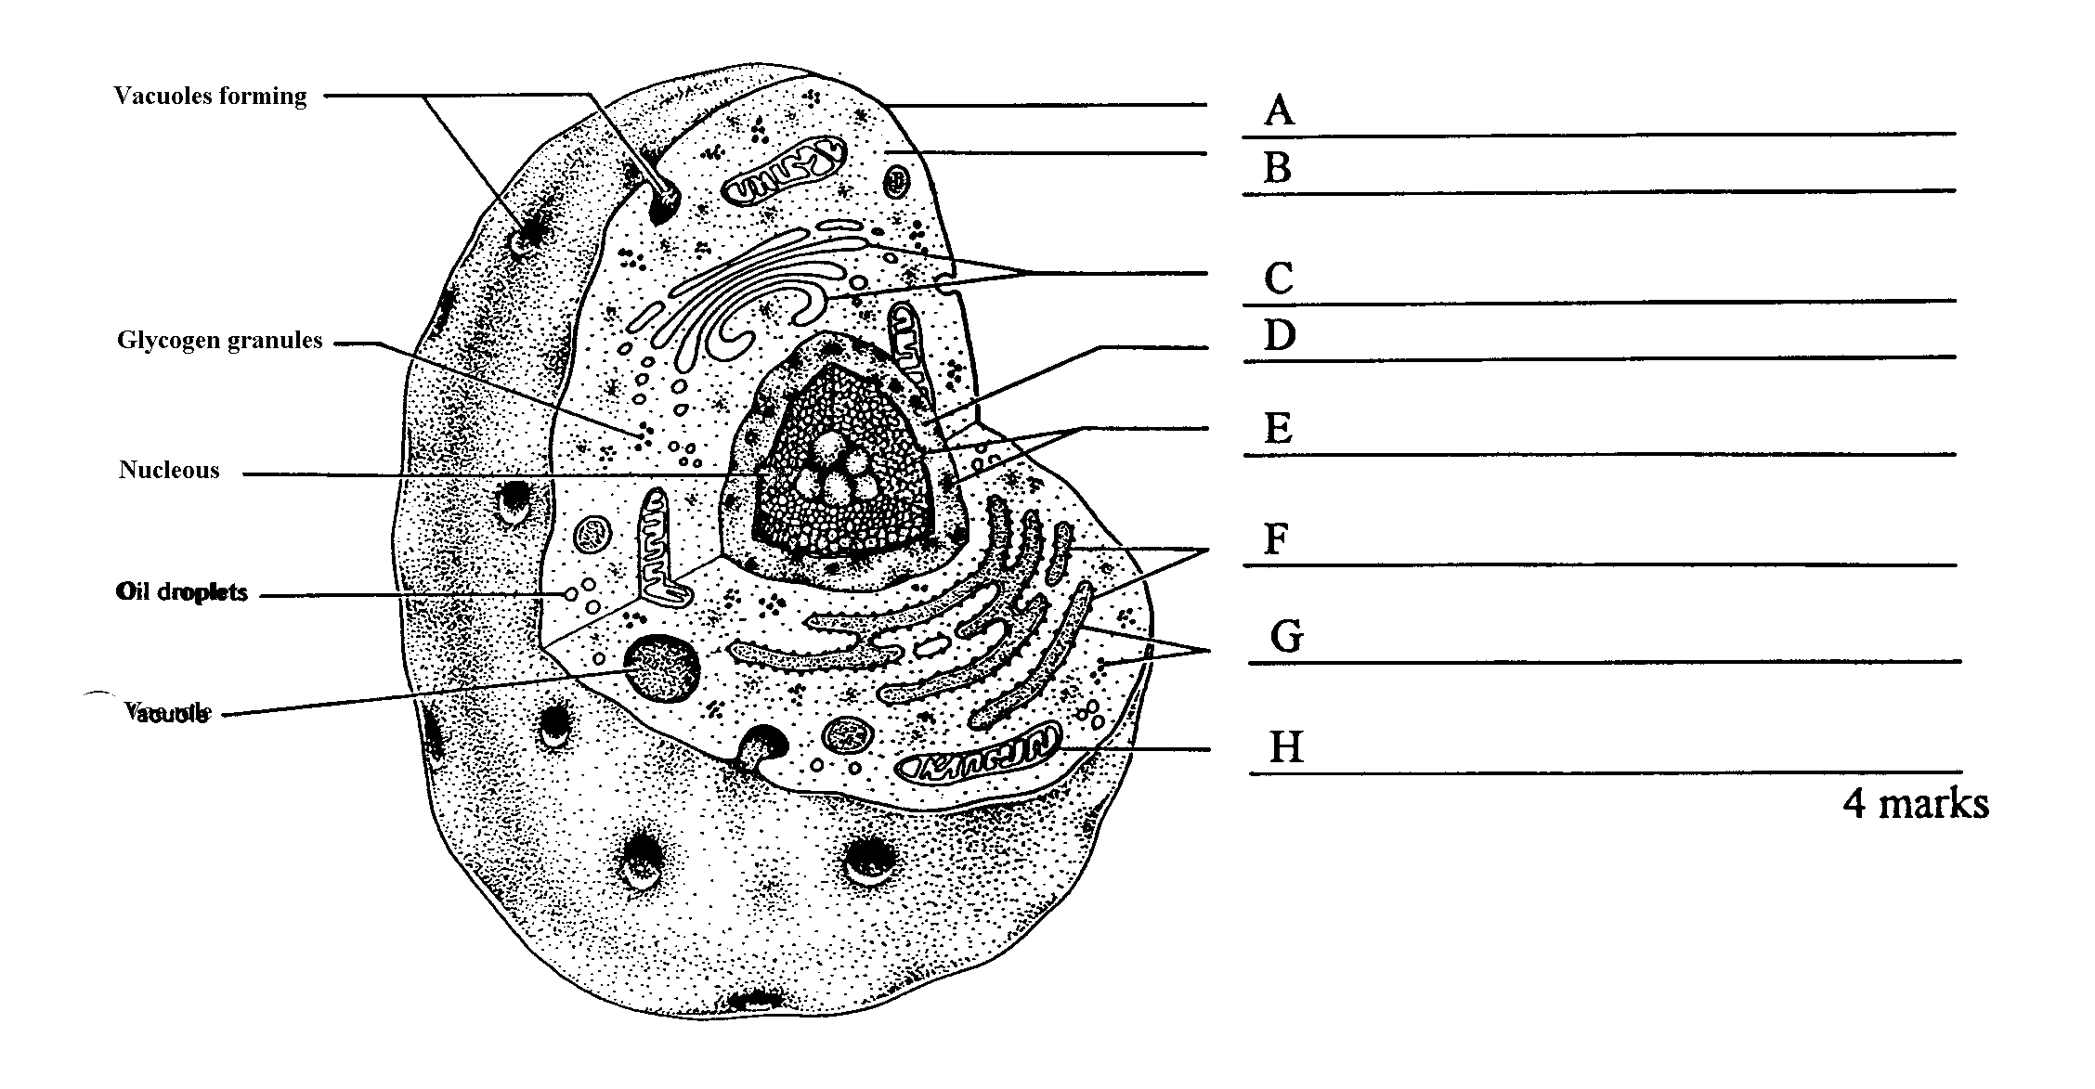

Vacules

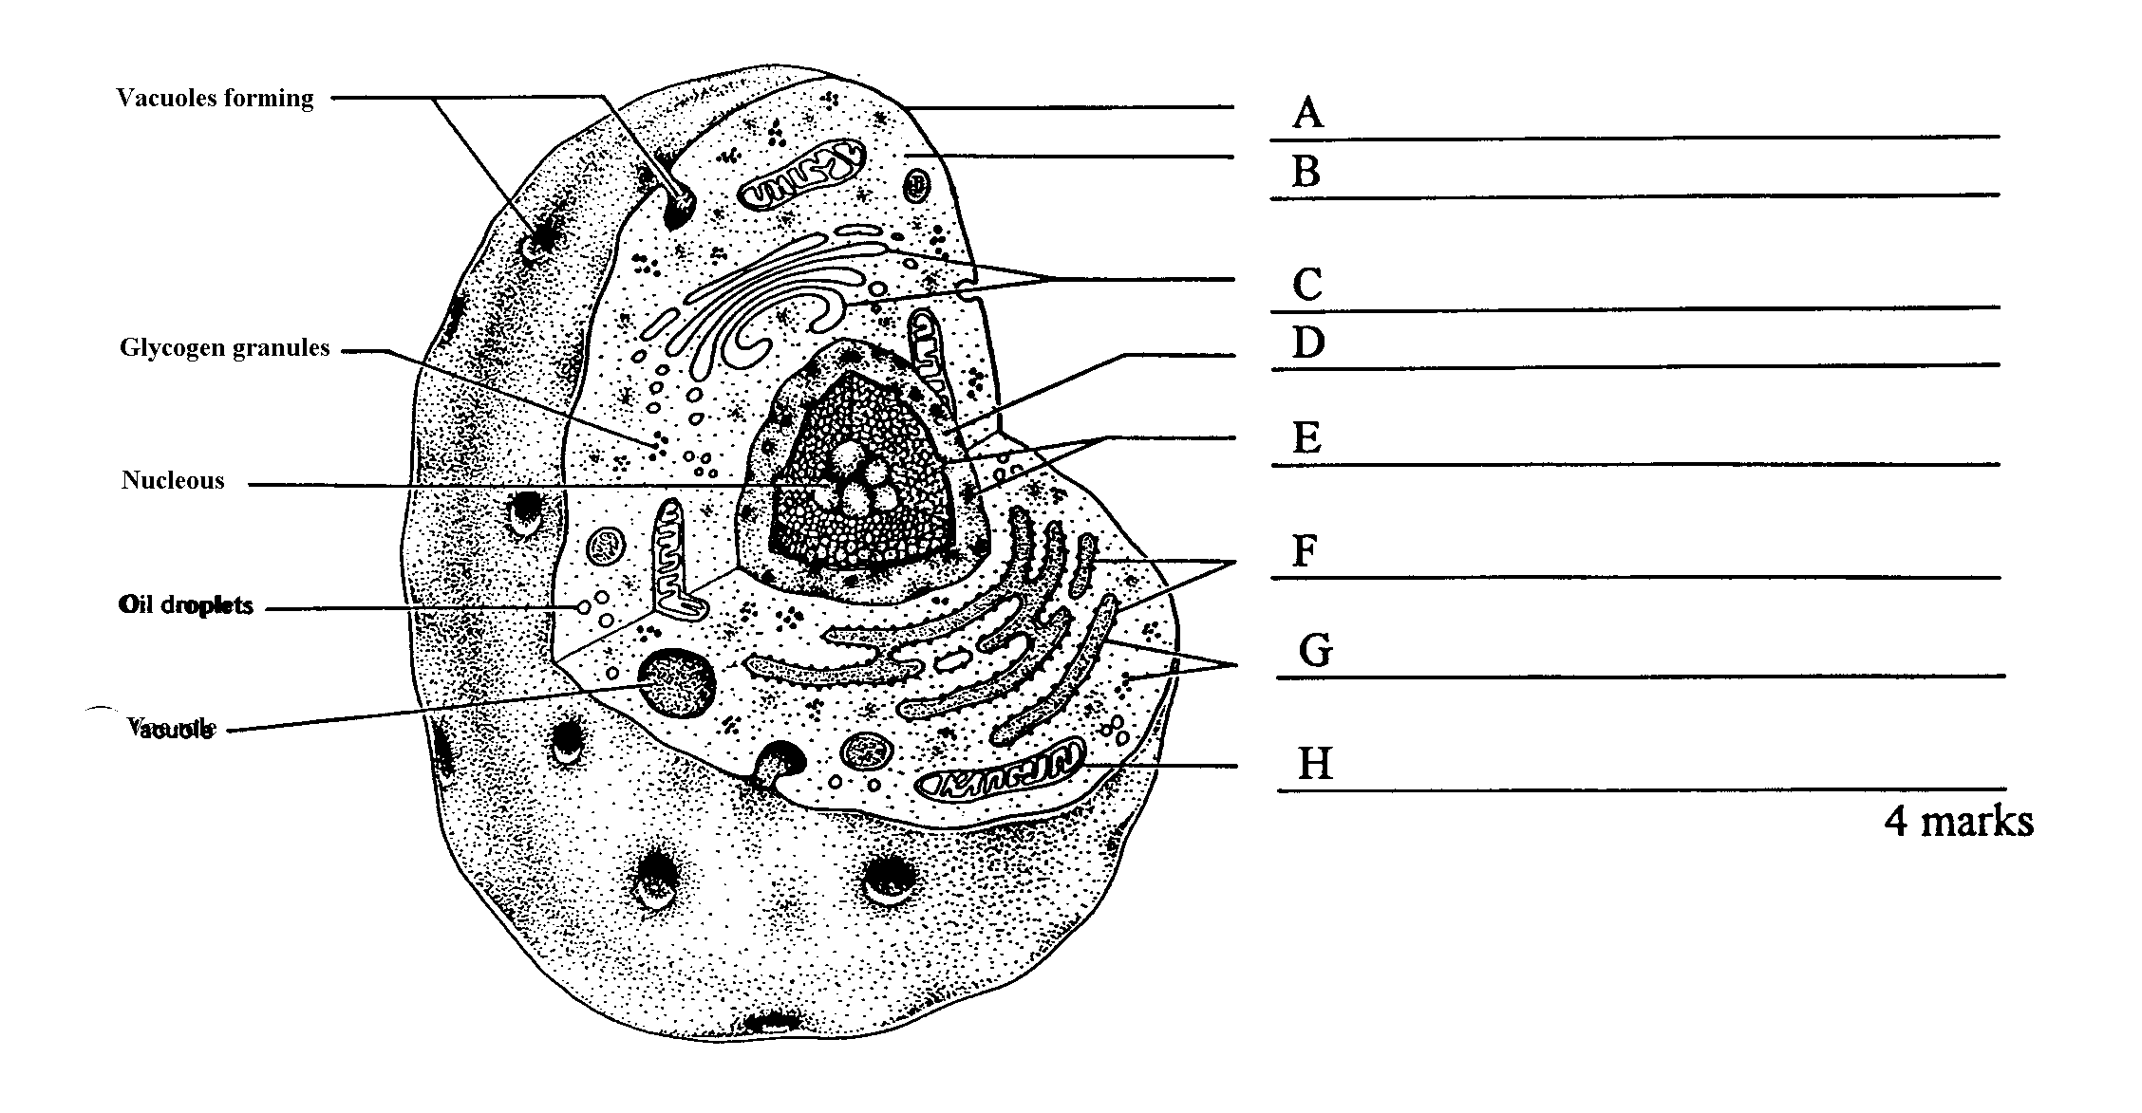

(dot)

b) In the diagram above, what is the function of:

(8 marks)

(dots)

Vacuole

Oil droplet

Structure C ______________________________________________________________

Structure G ______________________________________________________________

(2 marks)

c) (i) If this was a hard working muscle cell, name the immediate source of energy it would use.

_____________________________________________________________(1 mark)

(ii) How is this molecule changed to allow the release of energy for use in muscle contraction?

_____________________________________________________________(1 mark)

(iii) Explain how DNA can control protein production when it never leaves the nucleus.

__________________________________________________________________________________________________________________________________________________________________________________________________________________________________________________________________________________________________________________________________________________________________________________________________________________________________________________________________________________________________________

(3 marks)

**Question 52** (Total 5 marks)

The following diagrams show different stages of the mitotic division of one cell.

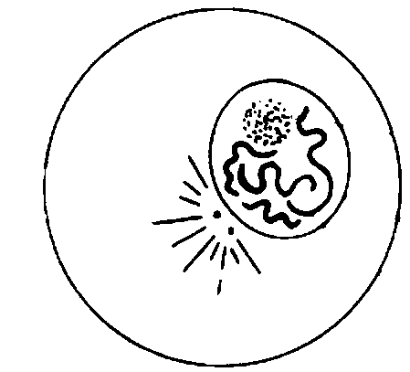

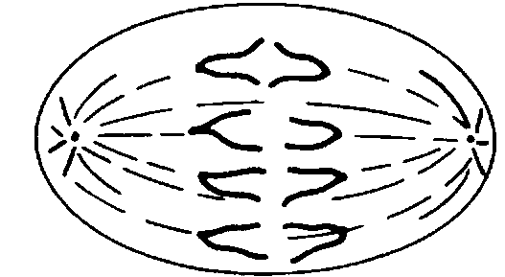

A

**B**

**C**

**D**

**E**

**F**

**G**

**H**

**I**

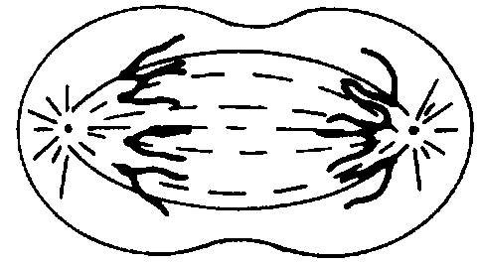

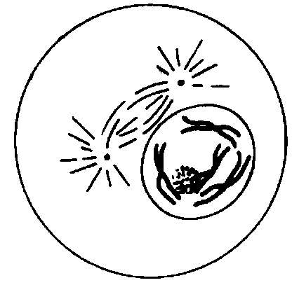

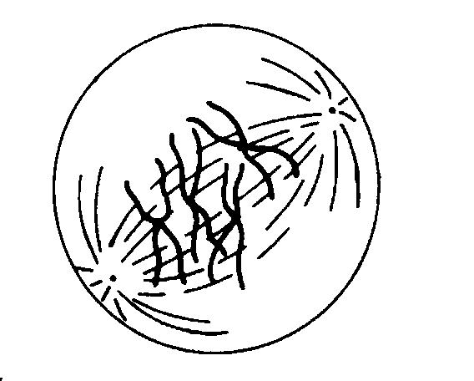

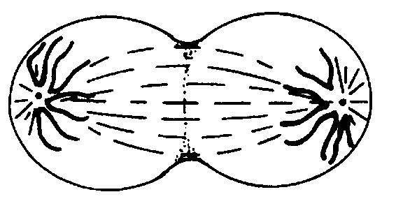

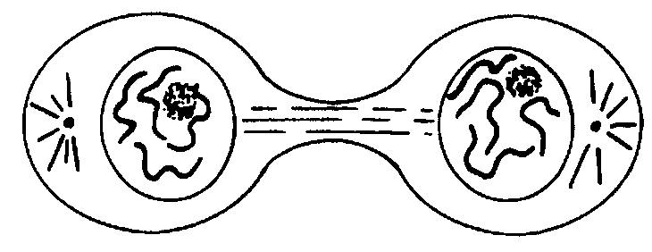

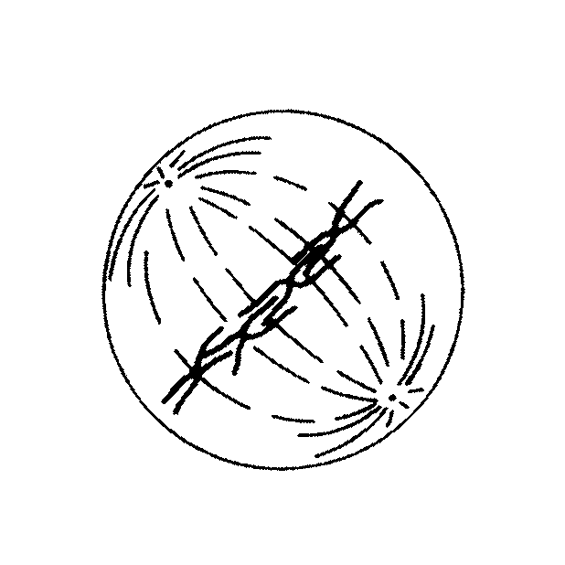

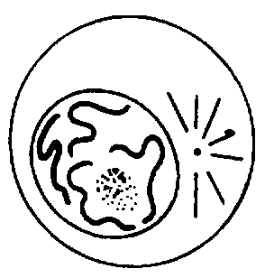

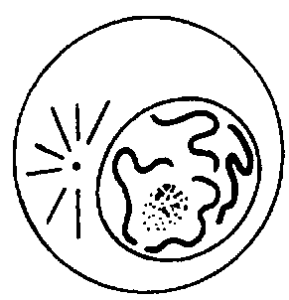

a)

|  |  |
| --- | --- |
| Stage | Briefly describe what is happening in the cell at this stage |
| B |  |
| D |  |
| E |  |

(3 marks)

(b) Using the letters A- I, identify when the cell is at the stage of mitosis called:

(i) Metaphase __________ (ii) Early anaphase ____________ (2 marks)

**Question 53** (Total 12 marks)

1. Match the function in the table with the appropriate letter from the heart diagram below.

**A**

**N**

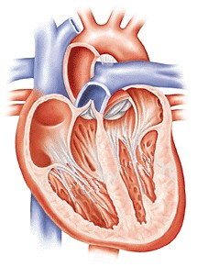

**M**

**B**

**L**

**C**

**K**

**J**

**I**

###### **D**

**H**

**G**

**E**

**F**

|  |  |
| --- | --- |
|  | Returns deoxygenated blood back to the heart. |
|  | Prevents blood from flowing back into the right atrium. |
|  | Blood is directed to the left lung though this structure. |
|  | Prevents atrioventricular valve from turning inside out. |
|  | Ensures that blood does not flow back into the ventricles. |
|  | Brings oxygenated blood back to the heart. |

(6 marks)

1. Use **large red arrows** to clearly indicate the direction of flow of OXYGENATED blood through the heart and its vessels. (1 mark)
2. What are the differences between the pulmonary and the systemic circulations?

_____________________________________________________________________________ _____________________________________________________________________________

_____________________________________________________________________________

(2 marks)

d) Explain the functions of the following structures:

1. Aorta________________________________________________________________

_____________________________________________________________________

_____________________________________________________________________

(ii) Pericardium__________________________________________________________

_____________________________________________________________________

_____________________________________________________________________

(iii) Septum______________________________________________________________

_____________________________________________________________________

_____________________________________________________________________

(3 marks)

**Question 54** (Total 10 marks)

The heart walls contain muscle cells that are able to contract.

a) Name the type of muscle cells. ______________________________________ (1 mark)

b) Name the type of organelle found in the cells that is directly responsible for the release of energy for the activity of these cells.

__________________________________________________________________ (1 mark)

c) A cell was observed under a microscope that had two ocular lenses as well as 5x, 20x and 60x objectives. Fill in the missing spaces to complete this table:

|  |  |  |  |
| --- | --- | --- | --- |
| Ocular | Objective | Magnification | Field of view |
| 10x | 5x | 50 |  |
| 15x | 20x | 300 | 300 micrometers |
| 15x | 60x | 900 |  |

(2 marks)

d) If the cell was 0.0l mm wide, how wide would it be in micrometres?

__________________________________________________________________ (1 mark)

e) Using the diagram below, explain what is happening in parts A to C.

_____________________________________________________________________________

_____________________________________________________________________________

_____________________________________________________________________________

_____________________________________________________________________________

_____________________________________________________________________________

_____________________________________________________________________________

____________________________________________________________________________

(3 marks)

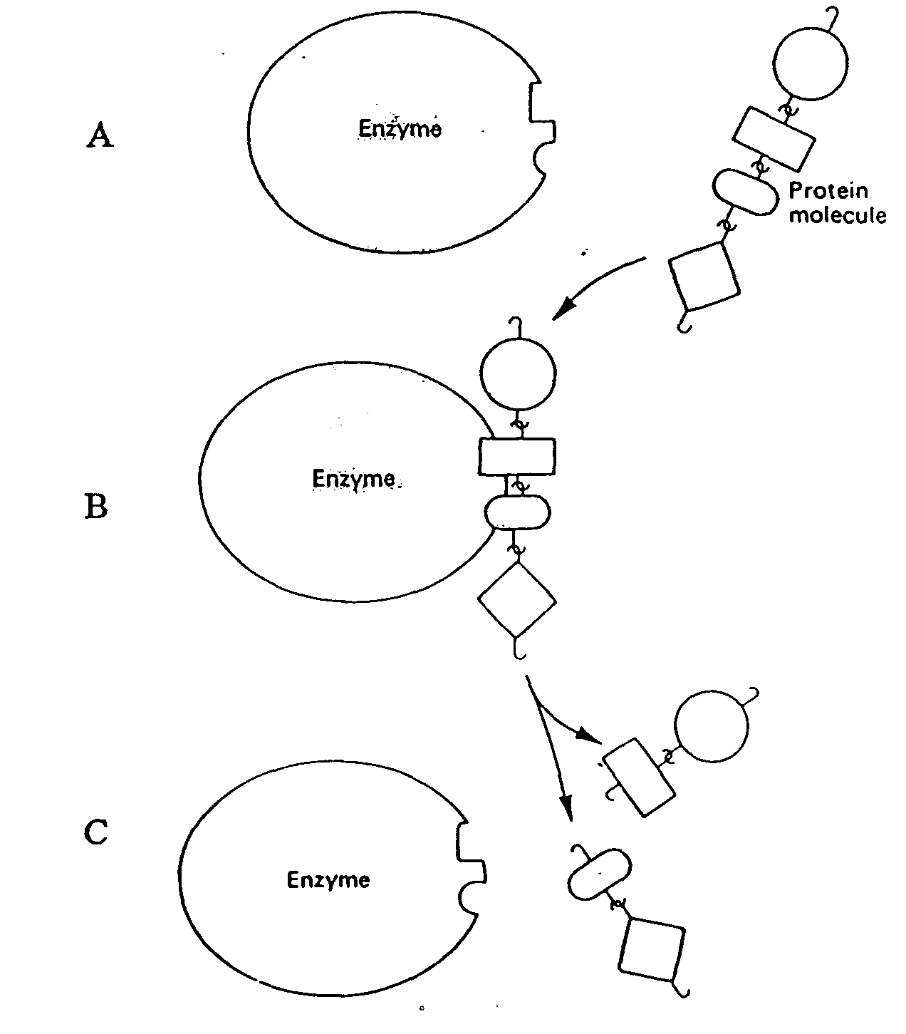

Enzyme

Enzyme

Enzyme

Protein molecule

(3 marks)

f) There are a number of factors that might affect the speed of this reaction.

List any two:

i.

ii.

(2 mark)

**Question 55** (Total 8 marks)

The diagram below shows the passage of red blood cells through a capillary in muscle tissue. Use this diagram to answer questions (a) and (b).

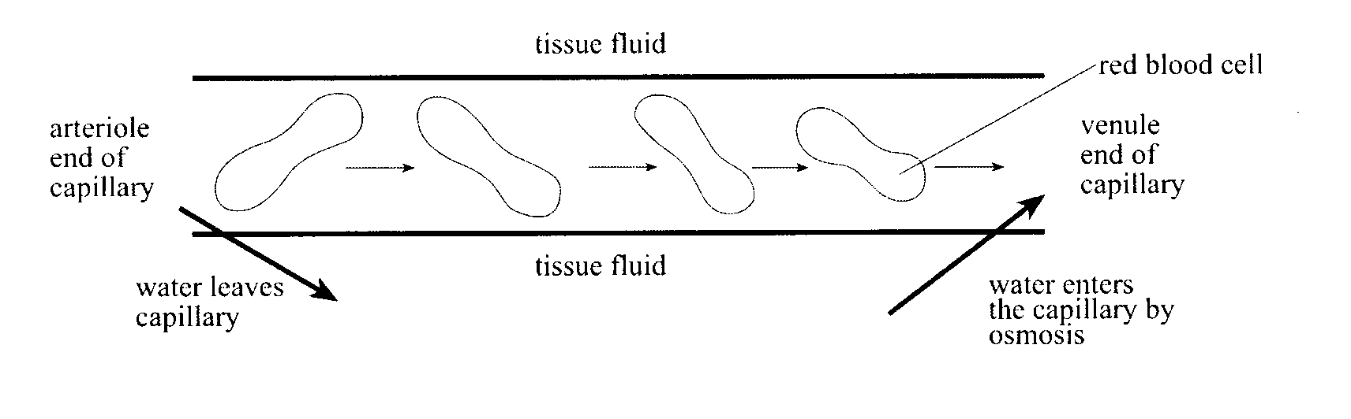

1. Explain why water enters the capillary at the venule end by osmosis.

_________________________________________________________________________________________________________________________________________________________________________________________________________________________________________________________________________________________________________________________________________________________________________________________________

(2 marks)

1. Describe **TWO** ways in which the composition of the blood at the arteriole end of the capillary differs from the composition of the blood at the venule end of the capillary.

_________________________________________________________________________________________________________________________________________________________________________________________________________________________________________________________________________________________________________________________________________________________________________________________________

(4 marks)

1. What structures are found in the blood but NOT in the interstitial fluid?

_________________________________________________________________________________________________________________________________________________________________________________________________________________________________________________________________________________________________________________________________________________________________________________________________

(2 marks)

**Question 56** (Total 9 marks)

The diagram below refers to parts (a) to (d) of Question 56.

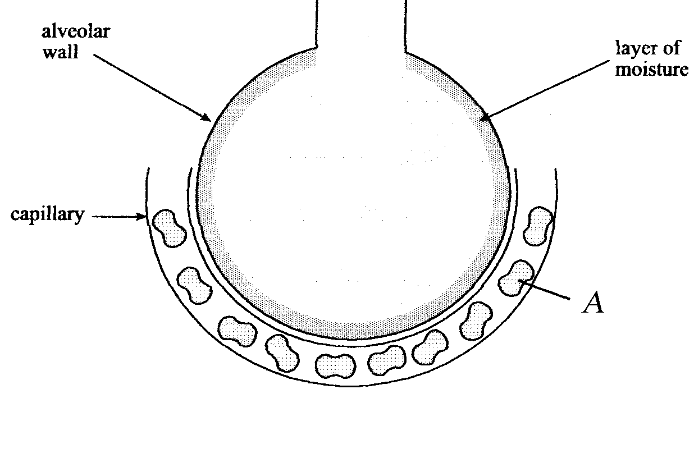

1. State **ONE** function of the layer of moisture that lines the alveolar wall.

_______________________________________________________________________________________________________________________________________________________________________________________________________________________________________

(1 mark)

(i) Name **ONE** other structural feature of the alveolar wall tissue.

______________________________________________________________________

(1 mark)

(1)

(ii) State **ONE** way in which the structural feature you listed in the question above facilities efficient gas exchange.

_______________________________________________________________________________________________________________________________________________________________________________________________________________

(1 mark)

c)

(i) Name the structure labelled A.

______________________________________________________________________

(1 mark)

(ii) What role does it perform in the gas exchange in the lungs?

________________________________________________________________________________________________________________________________________________________________________________________________________________________________________________________________________________________

(2 marks)

1. Complete the following table by describing how the following respiratory system components, or actions assist in normal lung function.

|  |  |
| --- | --- |
| **Component of the Respiratory System** | **Function** |
| Cilia |  |
| Mucus Secretion |  |
| Coughing |  |

(3 marks)

**Question 57** (Total 6 marks)

It is possible to dissolve and remove the outer hard shell of a hen’s egg using acid. This process leaves the cell membrane undamaged and the egg contents intact. Shells were removed in this way from three eggs and each egg was placed in one of three different solutions:

Solution 1: Distilled water

Solution 2: A dilute sugar solution

Solution 3: A concentrated sugar solution

The weight of the eggs was recorded at regular time intervals over 24 hours. The results are presented below:

a) Describe and explain how the weight of the egg in **Solution 1** changed over time.

________________________________________________________________________________________________________________________________________________________________________________________________________________________________________________________________________________________

(3 marks)

1. Describe and explain how the weight of the egg in **Solution 3** changed over time.

____________________________________________________________________________________________________________________________________________________________________________________________________________________________________________________________________________________________________________________

(3 marks)

**Question 58** (Total 10 marks)

(a) Complete the following paragraph on the respiratory system:

The pharynx is located at the back of the nose and mouth and is a common passage for both _________________ and _____________________. The larynx is located at the beginning of the ______________________ and contains the _________________. The _________________ is a specialised flap of skin that forms part of the larynx. Its job is to prevent any food or water from entering the trachea or windpipe during the act of _______________________. This means that breathing is briefly interrupted.

(3 marks)

(b) Complete the table below, describing the changes in the respiratory system during inhalation and exhalation.

|  |  |  |
| --- | --- | --- |
| **Structure or Respiratory Process** | **Inhalation** | **Exhalation** |
| **Diaphragm** |  |  |
| **Intercostal muscles** |  |  |
| **Thoracic cavity** |  |  |
| **Air pressure in the lungs** |  |  |
| **Lungs** |  |  |
| **Level of carbon dioxide in lungs** |  |  |
| **Level of oxygen in lungs** |  |  |

(7 marks)

**Question 59** (Total 13 marks)

In an experiment, ten test tubes containing digestive enzyme and its substrate were placed in a water bath at 370C. Each test tube had a different pH (acidity) value between 1 and 10. The reaction was stopped after a given time and the amount of product formed was measured. From the results, enzyme activities at pH values between 1 and 10 were calculated and are shown in the table below.

**Table 8: Enzyme Activity at Difference pH Values**

|  |  |
| --- | --- |
| **pH** | **Enzyme Activity (International Units)** |
| 1 | 8 |
| 2 | 10 |
| 3 | 15 |
| 4 | 28 |
| 5 | 35 |
| 6 | 77 |
| 7 | 90 |
| 8 | 110 |
| 9 | 76 |
| 10 | 24 |

1. Plot a line graph to display this data on the next page.

|  |  |  |  |  |  |  |  |  |  |  |  |  |  |  |  |  |  |  |  |  |  |  |  |  |  |  |  |  |  |  |  |  |  |  |  |  |  |  |  |
| --- | --- | --- | --- | --- | --- | --- | --- | --- | --- | --- | --- | --- | --- | --- | --- | --- | --- | --- | --- | --- | --- | --- | --- | --- | --- | --- | --- | --- | --- | --- | --- | --- | --- | --- | --- | --- | --- | --- | --- |
|  |  |  |  |  |  |  |  |  |  |  |  |  |  |  |  |  |  |  |  |  |  |  |  |  |  |  |  |  |  |  |  |  |  |  |  |  |  |  |  |
|  |  |  |  |  |  |  |  |  |  |  |  |  |  |  |  |  |  |  |  |  |  |  |  |  |  |  |  |  |  |  |  |  |  |  |  |  |  |  |  |
|  |  |  |  |  |  |  |  |  |  |  |  |  |  |  |  |  |  |  |  |  |  |  |  |  |  |  |  |  |  |  |  |  |  |  |  |  |  |  |  |
|  |  |  |  |  |  |  |  |  |  |  |  |  |  |  |  |  |  |  |  |  |  |  |  |  |  |  |  |  |  |  |  |  |  |  |  |  |  |  |  |
|  |  |  |  |  |  |  |  |  |  |  |  |  |  |  |  |  |  |  |  |  |  |  |  |  |  |  |  |  |  |  |  |  |  |  |  |  |  |  |  |
|  |  |  |  |  |  |  |  |  |  |  |  |  |  |  |  |  |  |  |  |  |  |  |  |  |  |  |  |  |  |  |  |  |  |  |  |  |  |  |  |
|  |  |  |  |  |  |  |  |  |  |  |  |  |  |  |  |  |  |  |  |  |  |  |  |  |  |  |  |  |  |  |  |  |  |  |  |  |  |  |  |
|  |  |  |  |  |  |  |  |  |  |  |  |  |  |  |  |  |  |  |  |  |  |  |  |  |  |  |  |  |  |  |  |  |  |  |  |  |  |  |  |
|  |  |  |  |  |  |  |  |  |  |  |  |  |  |  |  |  |  |  |  |  |  |  |  |  |  |  |  |  |  |  |  |  |  |  |  |  |  |  |  |
|  |  |  |  |  |  |  |  |  |  |  |  |  |  |  |  |  |  |  |  |  |  |  |  |  |  |  |  |  |  |  |  |  |  |  |  |  |  |  |  |
|  |  |  |  |  |  |  |  |  |  |  |  |  |  |  |  |  |  |  |  |  |  |  |  |  |  |  |  |  |  |  |  |  |  |  |  |  |  |  |  |
|  |  |  |  |  |  |  |  |  |  |  |  |  |  |  |  |  |  |  |  |  |  |  |  |  |  |  |  |  |  |  |  |  |  |  |  |  |  |  |  |
|  |  |  |  |  |  |  |  |  |  |  |  |  |  |  |  |  |  |  |  |  |  |  |  |  |  |  |  |  |  |  |  |  |  |  |  |  |  |  |  |
|  |  |  |  |  |  |  |  |  |  |  |  |  |  |  |  |  |  |  |  |  |  |  |  |  |  |  |  |  |  |  |  |  |  |  |  |  |  |  |  |
|  |  |  |  |  |  |  |  |  |  |  |  |  |  |  |  |  |  |  |  |  |  |  |  |  |  |  |  |  |  |  |  |  |  |  |  |  |  |  |  |
|  |  |  |  |  |  |  |  |  |  |  |  |  |  |  |  |  |  |  |  |  |  |  |  |  |  |  |  |  |  |  |  |  |  |  |  |  |  |  |  |
|  |  |  |  |  |  |  |  |  |  |  |  |  |  |  |  |  |  |  |  |  |  |  |  |  |  |  |  |  |  |  |  |  |  |  |  |  |  |  |  |
|  |  |  |  |  |  |  |  |  |  |  |  |  |  |  |  |  |  |  |  |  |  |  |  |  |  |  |  |  |  |  |  |  |  |  |  |  |  |  |  |
|  |  |  |  |  |  |  |  |  |  |  |  |  |  |  |  |  |  |  |  |  |  |  |  |  |  |  |  |  |  |  |  |  |  |  |  |  |  |  |  |
|  |  |  |  |  |  |  |  |  |  |  |  |  |  |  |  |  |  |  |  |  |  |  |  |  |  |  |  |  |  |  |  |  |  |  |  |  |  |  |  |
|  |  |  |  |  |  |  |  |  |  |  |  |  |  |  |  |  |  |  |  |  |  |  |  |  |  |  |  |  |  |  |  |  |  |  |  |  |  |  |  |
|  |  |  |  |  |  |  |  |  |  |  |  |  |  |  |  |  |  |  |  |  |  |  |  |  |  |  |  |  |  |  |  |  |  |  |  |  |  |  |  |
|  |  |  |  |  |  |  |  |  |  |  |  |  |  |  |  |  |  |  |  |  |  |  |  |  |  |  |  |  |  |  |  |  |  |  |  |  |  |  |  |
|  |  |  |  |  |  |  |  |  |  |  |  |  |  |  |  |  |  |  |  |  |  |  |  |  |  |  |  |  |  |  |  |  |  |  |  |  |  |  |  |
|  |  |  |  |  |  |  |  |  |  |  |  |  |  |  |  |  |  |  |  |  |  |  |  |  |  |  |  |  |  |  |  |  |  |  |  |  |  |  |  |
|  |  |  |  |  |  |  |  |  |  |  |  |  |  |  |  |  |  |  |  |  |  |  |  |  |  |  |  |  |  |  |  |  |  |  |  |  |  |  |  |
|  |  |  |  |  |  |  |  |  |  |  |  |  |  |  |  |  |  |  |  |  |  |  |  |  |  |  |  |  |  |  |  |  |  |  |  |  |  |  |  |
|  |  |  |  |  |  |  |  |  |  |  |  |  |  |  |  |  |  |  |  |  |  |  |  |  |  |  |  |  |  |  |  |  |  |  |  |  |  |  |  |
|  |  |  |  |  |  |  |  |  |  |  |  |  |  |  |  |  |  |  |  |  |  |  |  |  |  |  |  |  |  |  |  |  |  |  |  |  |  |  |  |
|  |  |  |  |  |  |  |  |  |  |  |  |  |  |  |  |  |  |  |  |  |  |  |  |  |  |  |  |  |  |  |  |  |  |  |  |  |  |  |  |
|  |  |  |  |  |  |  |  |  |  |  |  |  |  |  |  |  |  |  |  |  |  |  |  |  |  |  |  |  |  |  |  |  |  |  |  |  |  |  |  |
|  |  |  |  |  |  |  |  |  |  |  |  |  |  |  |  |  |  |  |  |  |  |  |  |  |  |  |  |  |  |  |  |  |  |  |  |  |  |  |  |
|  |  |  |  |  |  |  |  |  |  |  |  |  |  |  |  |  |  |  |  |  |  |  |  |  |  |  |  |  |  |  |  |  |  |  |  |  |  |  |  |
|  |  |  |  |  |  |  |  |  |  |  |  |  |  |  |  |  |  |  |  |  |  |  |  |  |  |  |  |  |  |  |  |  |  |  |  |  |  |  |  |
|  |  |  |  |  |  |  |  |  |  |  |  |  |  |  |  |  |  |  |  |  |  |  |  |  |  |  |  |  |  |  |  |  |  |  |  |  |  |  |  |
|  |  |  |  |  |  |  |  |  |  |  |  |  |  |  |  |  |  |  |  |  |  |  |  |  |  |  |  |  |  |  |  |  |  |  |  |  |  |  |  |
|  |  |  |  |  |  |  |  |  |  |  |  |  |  |  |  |  |  |  |  |  |  |  |  |  |  |  |  |  |  |  |  |  |  |  |  |  |  |  |  |

(6 marks)

***Note: Should you make a mistake, a spare sheet of graph paper is available at the end of this booklet.***

b) From the graph, what is the optimal pH for the enzyme being studied?

_____________________________________________________________________ (1 mark)

c) From your knowledge of the changes in pH along the digestive tract, in what part of the digestive tract would you expect this enzyme to operate?

_____________________________________________________________________ (1 mark)

d) Which organ **outside** of the digestive tract could have produced the enzyme being studied?

_____________________________________________________________________ (1 mark)

e) List the independent and dependent variables in this experiment.

1. Independent:___________________________________________________________
2. Dependent:_______________________________________________________

(2 marks)

f) List two variables that the experimenter would have controlled in this experiment.

_____________________________________________________________________________ _____________________________________________________________________________ (2 marks)

**Question 60** (Total 7 marks)

The diagram below shows a microscopic view of the wall of the ileum. One of the functions

of the ileum is absorption of digested food.

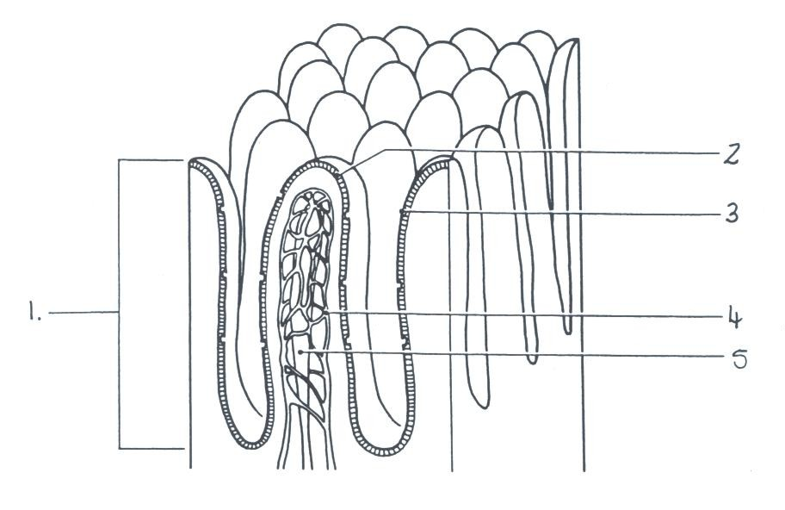

1. Name each of the following structures and explain how they aid in the process of

absorption.

1.___________________________________________________________________________

_____________________________________________________________________________

_______________________________________________________________________

4.___________________________________________________________________________

_____________________________________________________________________________

_______________________________________________________________________

5.___________________________________________________________________________

_____________________________________________________________________________

_______________________________________________________________________

(6 marks)

b) Give one other way in which the structures shown in the diagram are particularly well suited to their function of absorption of food.

_________________________________________________________________________

_____________________________________________________________________________

(1 mark)

**END OF SECTION B**

**SECTION C EXTENDED ANSWER QUESTIONS (40 marks)**

Answer questions on the paper provided in Booklet 2. Illustrate your answers with diagrams where appropriate. Up to TWO MARKS may be deducted for poorly structured answers, ie answers in point form or diagrams not explained in the text of your answer.

DO NOT WRITE YOUR ANSWERS IN PENCIL.

ANSWER **BOTH** QUESTION 1 **AND** QUESTION 2

**QUESTION 1:**

Once a muscle is stimulated, it requires energy to contract. The energy comes from a series of chemical reactions. Describe the processes which produce energy for the muscles of a runner in a sprint race, and also during an endurance race.

(Total 20 marks)

**AND**

**QUESTION 2:**

The circulatory system plays a vital role in our bodies.

1. Arteries, veins and capillaries are blood vessels. Describe **three** structural features of each.

(9 marks)

1. Explain how **one** of the structural features you have described **for each** of the blood vessels helps these blood vessels carry out their function.

(6 marks)

1. Describe how the circulatory system transports gases around the human body.

(5 marks)

(Total 20 marks)

**END OF SECTION C**

Spare sheet of graph paper

|  |  |  |  |  |  |  |  |  |  |  |  |  |  |  |  |  |  |  |  |  |  |  |  |  |  |  |  |  |  |  |  |  |  |  |  |  |  |  |  |  |
| --- | --- | --- | --- | --- | --- | --- | --- | --- | --- | --- | --- | --- | --- | --- | --- | --- | --- | --- | --- | --- | --- | --- | --- | --- | --- | --- | --- | --- | --- | --- | --- | --- | --- | --- | --- | --- | --- | --- | --- | --- |
|  |  |  |  |  |  |  |  |  |  |  |  |  |  |  |  |  |  |  |  |  |  |  |  |  |  |  |  |  |  |  |  |  |  |  |  |  |  |  |  |  |
|  |  |  |  |  |  |  |  |  |  |  |  |  |  |  |  |  |  |  |  |  |  |  |  |  |  |  |  |  |  |  |  |  |  |  |  |  |  |  |  |  |
|  |  |  |  |  |  |  |  |  |  |  |  |  |  |  |  |  |  |  |  |  |  |  |  |  |  |  |  |  |  |  |  |  |  |  |  |  |  |  |  |  |
|  |  |  |  |  |  |  |  |  |  |  |  |  |  |  |  |  |  |  |  |  |  |  |  |  |  |  |  |  |  |  |  |  |  |  |  |  |  |  |  |  |
|  |  |  |  |  |  |  |  |  |  |  |  |  |  |  |  |  |  |  |  |  |  |  |  |  |  |  |  |  |  |  |  |  |  |  |  |  |  |  |  |  |
|  |  |  |  |  |  |  |  |  |  |  |  |  |  |  |  |  |  |  |  |  |  |  |  |  |  |  |  |  |  |  |  |  |  |  |  |  |  |  |  |  |
|  |  |  |  |  |  |  |  |  |  |  |  |  |  |  |  |  |  |  |  |  |  |  |  |  |  |  |  |  |  |  |  |  |  |  |  |  |  |  |  |  |
|  |  |  |  |  |  |  |  |  |  |  |  |  |  |  |  |  |  |  |  |  |  |  |  |  |  |  |  |  |  |  |  |  |  |  |  |  |  |  |  |  |
|  |  |  |  |  |  |  |  |  |  |  |  |  |  |  |  |  |  |  |  |  |  |  |  |  |  |  |  |  |  |  |  |  |  |  |  |  |  |  |  |  |
|  |  |  |  |  |  |  |  |  |  |  |  |  |  |  |  |  |  |  |  |  |  |  |  |  |  |  |  |  |  |  |  |  |  |  |  |  |  |  |  |  |
|  |  |  |  |  |  |  |  |  |  |  |  |  |  |  |  |  |  |  |  |  |  |  |  |  |  |  |  |  |  |  |  |  |  |  |  |  |  |  |  |  |
|  |  |  |  |  |  |  |  |  |  |  |  |  |  |  |  |  |  |  |  |  |  |  |  |  |  |  |  |  |  |  |  |  |  |  |  |  |  |  |  |  |
|  |  |  |  |  |  |  |  |  |  |  |  |  |  |  |  |  |  |  |  |  |  |  |  |  |  |  |  |  |  |  |  |  |  |  |  |  |  |  |  |  |
|  |  |  |  |  |  |  |  |  |  |  |  |  |  |  |  |  |  |  |  |  |  |  |  |  |  |  |  |  |  |  |  |  |  |  |  |  |  |  |  |  |
|  |  |  |  |  |  |  |  |  |  |  |  |  |  |  |  |  |  |  |  |  |  |  |  |  |  |  |  |  |  |  |  |  |  |  |  |  |  |  |  |  |
|  |  |  |  |  |  |  |  |  |  |  |  |  |  |  |  |  |  |  |  |  |  |  |  |  |  |  |  |  |  |  |  |  |  |  |  |  |  |  |  |  |
|  |  |  |  |  |  |  |  |  |  |  |  |  |  |  |  |  |  |  |  |  |  |  |  |  |  |  |  |  |  |  |  |  |  |  |  |  |  |  |  |  |
|  |  |  |  |  |  |  |  |  |  |  |  |  |  |  |  |  |  |  |  |  |  |  |  |  |  |  |  |  |  |  |  |  |  |  |  |  |  |  |  |  |
|  |  |  |  |  |  |  |  |  |  |  |  |  |  |  |  |  |  |  |  |  |  |  |  |  |  |  |  |  |  |  |  |  |  |  |  |  |  |  |  |  |
|  |  |  |  |  |  |  |  |  |  |  |  |  |  |  |  |  |  |  |  |  |  |  |  |  |  |  |  |  |  |  |  |  |  |  |  |  |  |  |  |  |
|  |  |  |  |  |  |  |  |  |  |  |  |  |  |  |  |  |  |  |  |  |  |  |  |  |  |  |  |  |  |  |  |  |  |  |  |  |  |  |  |  |
|  |  |  |  |  |  |  |  |  |  |  |  |  |  |  |  |  |  |  |  |  |  |  |  |  |  |  |  |  |  |  |  |  |  |  |  |  |  |  |  |  |
|  |  |  |  |  |  |  |  |  |  |  |  |  |  |  |  |  |  |  |  |  |  |  |  |  |  |  |  |  |  |  |  |  |  |  |  |  |  |  |  |  |
|  |  |  |  |  |  |  |  |  |  |  |  |  |  |  |  |  |  |  |  |  |  |  |  |  |  |  |  |  |  |  |  |  |  |  |  |  |  |  |  |  |
|  |  |  |  |  |  |  |  |  |  |  |  |  |  |  |  |  |  |  |  |  |  |  |  |  |  |  |  |  |  |  |  |  |  |  |  |  |  |  |  |  |
|  |  |  |  |  |  |  |  |  |  |  |  |  |  |  |  |  |  |  |  |  |  |  |  |  |  |  |  |  |  |  |  |  |  |  |  |  |  |  |  |  |
|  |  |  |  |  |  |  |  |  |  |  |  |  |  |  |  |  |  |  |  |  |  |  |  |  |  |  |  |  |  |  |  |  |  |  |  |  |  |  |  |  |
|  |  |  |  |  |  |  |  |  |  |  |  |  |  |  |  |  |  |  |  |  |  |  |  |  |  |  |  |  |  |  |  |  |  |  |  |  |  |  |  |  |
|  |  |  |  |  |  |  |  |  |  |  |  |  |  |  |  |  |  |  |  |  |  |  |  |  |  |  |  |  |  |  |  |  |  |  |  |  |  |  |  |  |
|  |  |  |  |  |  |  |  |  |  |  |  |  |  |  |  |  |  |  |  |  |  |  |  |  |  |  |  |  |  |  |  |  |  |  |  |  |  |  |  |  |
|  |  |  |  |  |  |  |  |  |  |  |  |  |  |  |  |  |  |  |  |  |  |  |  |  |  |  |  |  |  |  |  |  |  |  |  |  |  |  |  |  |
|  |  |  |  |  |  |  |  |  |  |  |  |  |  |  |  |  |  |  |  |  |  |  |  |  |  |  |  |  |  |  |  |  |  |  |  |  |  |  |  |  |
|  |  |  |  |  |  |  |  |  |  |  |  |  |  |  |  |  |  |  |  |  |  |  |  |  |  |  |  |  |  |  |  |  |  |  |  |  |  |  |  |  |
|  |  |  |  |  |  |  |  |  |  |  |  |  |  |  |  |  |  |  |  |  |  |  |  |  |  |  |  |  |  |  |  |  |  |  |  |  |  |  |  |  |
|  |  |  |  |  |  |  |  |  |  |  |  |  |  |  |  |  |  |  |  |  |  |  |  |  |  |  |  |  |  |  |  |  |  |  |  |  |  |  |  |  |
|  |  |  |  |  |  |  |  |  |  |  |  |  |  |  |  |  |  |  |  |  |  |  |  |  |  |  |  |  |  |  |  |  |  |  |  |  |  |  |  |  |
|  |  |  |  |  |  |  |  |  |  |  |  |  |  |  |  |  |  |  |  |  |  |  |  |  |  |  |  |  |  |  |  |  |  |  |  |  |  |  |  |  |